Rosanna Scout Group
10th Birthday Party!

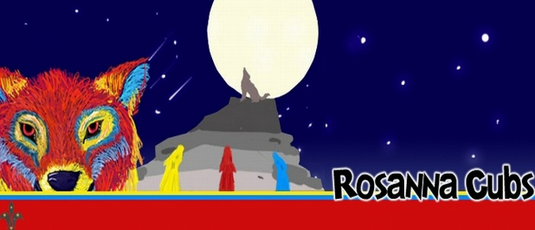

Rosanna Scout Group recommenced in 2007 with Wayne (Akela) and Laura (Chil) leading 4 Cubs. Since that time the Cub Pack has grown to more than 30 Cubs (with a waiting list) and after starting in 2009, Rosanna Scouts lead by Michelle has grown to more than 30 Scouts (with a waiting list). Rosanna Scout Group also boasts 5 Venturers and 2 Rovers.

Let’s celebrate our first 10 years!!!!

When: Tuesday 14th March 2017, 7pm
Cost: Free to Cubs/Scouts/Leaders and their families
Supplied: BBQ, Fairy Bread, Cordial and Celebration cake!
Please bring: Plate of party food to share
Wear: All members of the Scout Association must wear full uniform
RSVP: Please add your name and what you’re bringing to the list in the hall (please check what is already on the list try to bring something different)
Note: Some Scouting and other VIPs will join us on the night and 1 Grey Wolf will be presented

